LEATHERBACK (ENG) – De Geharde Rug (NL)

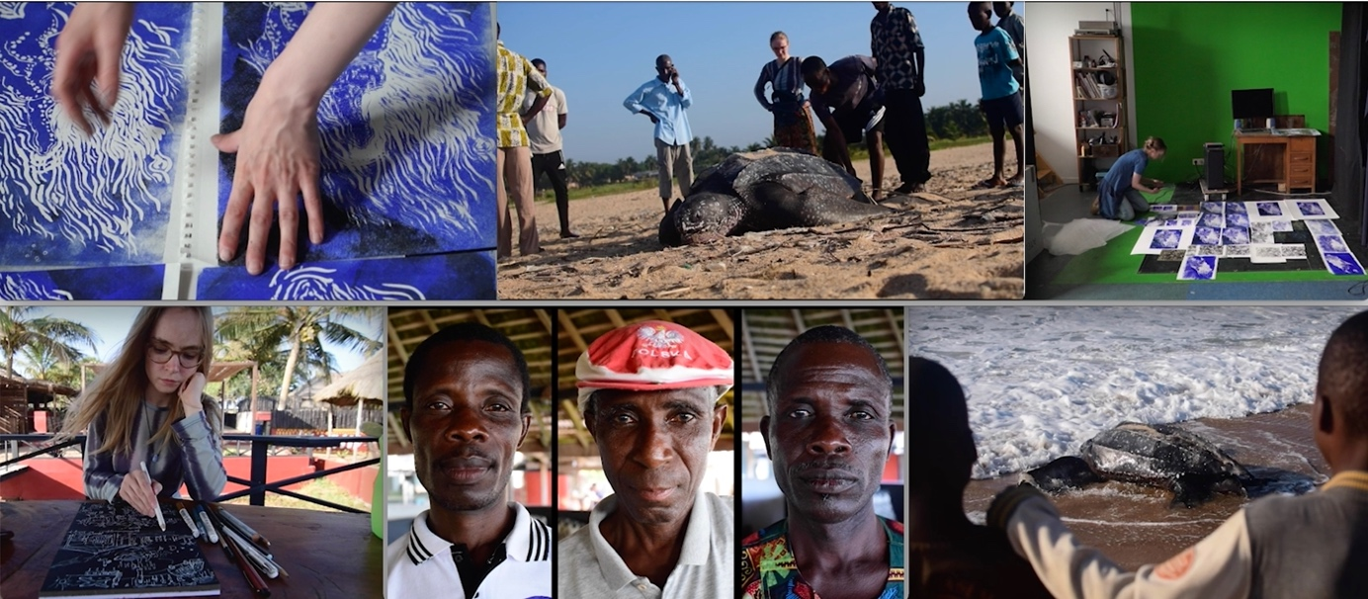
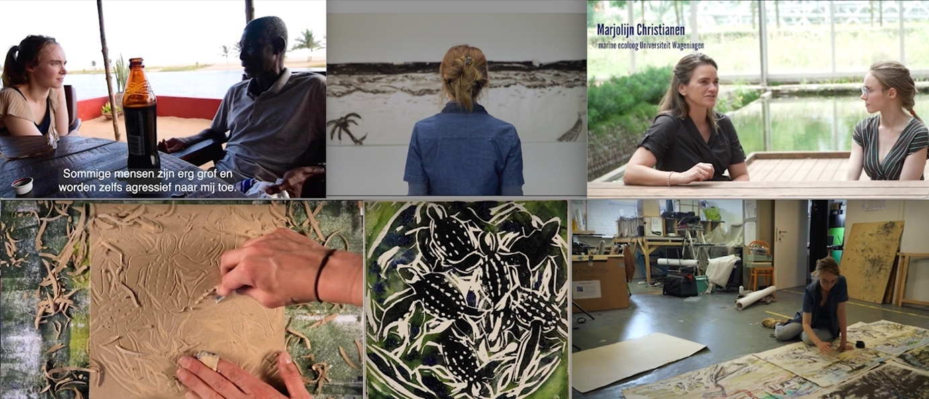

Duration: 29 minutes
Language: Dutch or English
First version: august 2021
Second version: 2022
Makers: Mirthe Dokter and Rian van den Boom
Teaser 1: http://www.mirthedokter.nl/?page_id=2117
Teaser 2: https://youtu.be/zLICmhexQXk

Synopsis:

Logline:
- A portrait of the ancient seaturtle and her protectors in Ghana by a Dutch woman/visual artist, reflecting climate changes, social habits and cultural differences.

- Climate change, social habits and cultural differences from the eyes of the sea turtle, Ghanaian protectors and a Dutch artist.

- A story about spending time for something unusual, as a sea turtle.

Synopsis:
Artist Mirthe Dokter has been fascinated by the huge prehistoric leatherback sea turtle since she was a child. She sets off to Ghana, where she meets the turtle and its protectors in person.
This unconventional documentary named ‘De Geharde Rug’ (NL) / 'Leatherback' (ENG) shows an intriguing portrait of the leatherback sea turtle, an animal threatened with extinction. In Ghana, Mirthe meets ‘Uncle Raf’, the leader of a turtle team in a small fishing town at the coastline. Slowly, almost unnoticed, she gets entangled in the web of all the difficulties that come with protecting this ancient animal. She records her story in a painted diary, that she shares with a marine ecologist in Holland.
In an ongoing situation of poverty and climate change, can an artist help to unravel the problems of Raf and his team?
This movie tries to find an answer on the question: what can be the role of artistic storytelling and art in scientific research and the global conversation about animal conservation. By sharing personal experiences in an artistic way, this movie tries to reveal a relevant case-study of an under-researched territory.
This documentary is one of the results of a long-term research in Ghana by Mirthe Dokter. In 2022 she is planning to go back to Ghana and finish the project with a last part (artwork). In the documentary Mirthe used her artistic archive to summarize her experiences and the stories of the people she met. She reflects in film and in stop motion animation.

Short:

This unconventional docu shows an intriguing portrait of the leatherback sea turtle, threatened with extinction. In Ghana, artist Mirthe meets ‘Uncle Raf’, the leader of a turtle team in a small fishing town. Slowly, she gets entangled in the web of all the difficulties that come with protecting this ancient animal. She records her story in a painted diary, that she shares with a marine ecologist in Holland.

Note
This documentary is one of the results of a long-term research in Ghana by Mirthe Dokter. In 2022 she is planning to go back to Ghana and finish the project with a last part (artwork). In the documentary Mirthe used her artistic archive to summarize her experiences and the stories of the people she met. She reflects in film and in stop motion animation.

Makers

Biography Mirthe Dokter:
In 2014 Mirthe Dokter (Dutch, living in Arnhem and Brussels) graduated from ArtEZ School of the Arts, music theatre department, with a minor in Fine Arts. After her degree, she worked as a theatre maker, visual artist and singer. As a trans disciplinary maker, she combines painting, ceramics, analogue projections, film, movement, research and singing. Mirthe puts a spotlight on hidden subjects in film, exhibitions or on stage. The visitor is always part of the performance, as participating viewer or maker. In her work she looks for collaboration with scientists and with marginalized social groups. Mirthe made the following performances on various European stages: ‘Leatherback’ (a solo about a sea turtle conservation team in Ghana), ‘STRIJD’ and ‘De Balts’ (2018 and 2021, scientific comedies on animal behavior with Tim Hammer) and ‘Kijk, ik zoek!’ (2016, a live painted picture book about a refugee).
In 2018 she won the young makers price/Puppet International and in 2019 she won the Ruth van der Steenhoven-prijs/NVP-Unima. Since 2020 Mirthe works on her social-artistic installation 'het volk der introverten' with several museums. Since 2018 Mirthe is working on an artistic research about a sea turtle conservation team in West-Africa. Together with filmmaker Rian van den Boom and scientist Marjolijn Christianen she made her first documentary about this research.

Long:
In 2014 Mirthe Dokter (Dutch, living in Arnhem and Brussels) graduated from ArtEZ School of the Arts, music theatre department, with a minor in Fine Arts. After her degree, she worked as a theatre maker, visual artist and singer. As a trans disciplinary maker, she combines painting, ceramics, analogue projections, film, movement, research and singing. Mirthe puts a spotlight on hidden subjects in film, exhibitions or on stage. The visitor is always part of the performance, as participating viewer or maker. In her work she looks for collaboration with scientists and with marginalized social groups. Mirthe made the following performances on various European stages: ‘Leatherback’ (a solo about a sea turtle conservation team in Ghana), ‘STRIJD’ and ‘De Balts’ (2018 and 2021, scientific comedies on animal behavior with Tim Hammer) and ‘Kijk, ik zoek!’ (2016, a live painted picture book about a refugee).
In 2018 she won the young makers price/Puppet International and in 2019 she won the Ruth van der Steenhoven-prijs/NVP-Unima. Since 2020 Mirthe works on her social-artistic installation 'het volk der introverten' with several museums. Since 2018 Mirthe is working on an artistic research about a sea turtle conservation team in West-Africa. Together with filmmaker Rian van den Boom and scientist Marjolijn Christianen she made her first documentary about this research. Mirthe will exchange the docu with the people in Ghana/West-Africa in July 2023. She will continue her research, working on part two of the documentary in animation, with film production house Graphoui in Brussels. She connects the docu with conservation- and nature associations, such as research groups, WWF and the international sea turtle symposium. She calls herself an ecology-artist: researching ecology issues in an artistic way, together with scientists, using artistic storytelling. Since 2022 Mirthe works on a panorama painting of 100 meters about the feeling of getting used to a new place/situation.

Short: The work of Mirthe Dokter (2014, ArtEZ School of the Arts, Music Theatre and Fine Arts) is characterized by the combination of visual art (painting, carving, ceramics, analogue projections, photo, film) with performance (singing, theatre, movement). Mirthe puts a spotlight on hidden subjects in film, exhibitions or on stage. In her work she looks for collaboration with scientists and with marginalized social groups. Here-fo she collaborates with museums, theatre groups, festivals and filmmakers.

Biography Rian van den Boom:
In 1996 Rian van den Boom graduated from ArtEZ School of the Arts Arnhem, majoring in directing theatre. In the period after her graduation she directed several theater productions. In 2002 she started her film career, working with a broadcaster on the eight-part television series 'De Gebroeders van Es'. With that, her love for film was born. After filming a second satirical series, she developed an urge to make documentaries, focusing on human behavior. She started making documentaries, because she wanted to tell stories. Since then she made various documentary series and films, and discovered many ways of telling stories. The art of storytelling, of interpreting a story in such a way that someone else looks at reality in a new way, remains her mission. By working with Mirthe Dokter she combines her focus on human behavior with a more artistic way of storytelling.

Short: In 1996 Rian van den Boom graduated from ArtEZ School of the Arts Arnhem, majoring in directing theatre. In the period after her graduation she directed several theater productions. In 2002 she started her film career, working with a broadcaster on the eight-part television series 'De Gebroeders van Es'. She made various documentaries, films and series, focusing on human behavior, often showed on national television.

filmpgraphy Rian van den Boom:
De Geharde Rug | The leatherback, short documentary, ’30 minutes, 2021
FutureMe, short documentary, ’15 minutes, 2020
Ondertussen in Museum Arnhem, 10 part documentary series, 2019
Moederliefde ’54 minutes, documentary, 2017.
Die kleine is alles voor mij, ’52 minutes, documentary, 2015.
Hoefnagels 6-part docudrama, 2012
Caribbean Netherlands, 6 part documentary series, 2011
In blijde verwachting, 6-part portrait series, 2010
De voorstelling van mijn leven, ’50 minutes, documentary, 2010
Schatten van Brabant, 4-part documentary series, 2010
Kop dicht, voetballen, 6-part documentary series, 2008
Mijn vaders voettocht, ’50 minutes, documentary, 2007
IDFA documentary workshop, 2005, teached by Aliona van der Horst and Heddy Honigmann

Filmography Mirthe Dokter:
De Geharde Rug | The Leatherback, short documentary, ’30 minutes, 2021
Even niet, musical clip for KWATTA theatre company ‘15 minutes, 2021
De Reiger, animation clip for Orchestra De Ereprijs (analogue overhead projections) ’20 minutes, 2020
Confused Mind, animation clip for musician Tonio Geugelin (analogue overhead projections), ‘5 minutes, 2018
Overhead projection demonstration – item in TV-program ‘Podium Witteman’ NPO, 2017
Other activities: Independent visual artist, theatre maker and singer since 2014.

List of performances/artworks:
STRIJD – physical musical theatre, 2021-22
Het Volk der Introverten – visual artwork/installation, 2020-22
Portretten panorama 'Op het Puin' - visual artwork/painting 2021
Ik Moed – visual musical theatre, 2020
Strandbroeders – photo- and illustration exhibition, 2020
Leatherback – visual musical theatre, 2018
De Balts – visual musical theatre, 2017
Kijk, ik zoek! – youth theatre, 2016
IK WOU – visual musical theatre, 2014

Directors statement (Mirthe Dokter):

There are several strong reasons that motivated me for making this documentary:

- During my visits in Ghana I became aware of the position of West-Afrika within global conversations. The voice of this part of the world is often forgotten, or skipped, in global conversations about conservation of nature and politics that are involved with this. I think it is important to give sound to this area, and especially to the thoughts of the people living there. If I can help showing their observations to the outside world, I hope I can be a small bridge for them to the outside.
- When I met marine ecologist Marjolijn Christianen at the Wageningen University in 2019, I was very surprised that this nesting area of the seaturtle in Ghana was not in the picture (see point 1). Marjolijn told me West-Afrika is an area not many researchers go to, because of the lack of infrastructure. Marjolijn was very surprised hearing my observations about the seaturtle at the coastline in Ghana, and the social problems that comes with it. My personal story helped her to have a better view about this specific small habitat in the big migratory route the seaturtle. By giving a personal face to a small ‘case study area’, like this one, it is possible to have a clearer view on the situation of the seaturtle in general.

Scientist statement (Marjolijn Christianen (WUR):

Migratory charismatic endangered species such as sea turtles, have a complex life cycles, of which multiple life stages have not yet been investigated. In addition, current narratives between scientists, the public, conservationists and policy makers currently fail to really connect the different stakeholders in their journey to successful conservation action plans at a global scale. Investigating a migrating animal species is expensive and time-consuming and requires a broad perspective. In this research, a scientist - Marjolijn- and an artist – Mirthe - aim to develop a new narrative through storytelling to which scientific data and personal experiences can be attached. Herein the connection between science and art is made with the aim of bridging the gaps in knowledge. We are looking for a way to make more efficient connections, making the story of the sea turtle both clearer and more accessible within science and beyond. With the collaboration we aim to investigate how scientific and personal storytelling can contribute to a new narrative to aid conservation of charismatic migratory species. This documentary is a first result in this ongoing collaboration.

Additional Info:
The documentary is available in different versions:
1. An English version: English voice overs and English subtitles when dialogues are in Dutch).
2. The original Dutch version: Dutch voice overs and Dutch subtitles when dialogues are in English.
3. A mix: English subtitles, with Dutch voice overs (the voice overs are subtitled in English)

In the summer of 2022 I will go back to Ghana, to exchange the film with the community. Out of this journey I am planning on making a second part of the documentary (short epilogue) about this moment of exchange and the current situation. I will use mostly animation in this part. I will make this part in collaboration with Atelier Graphoui Brussels. I hope it will be finished in the autumn of 2022 (in total maximum 45 minutes, first part is now 30 minutes).
For the docu I work with marine ecologist associate professor Marjolijn Christianen (WUR), together we can arrange a Q&A and more.

Credits:

Camera, animation, direction: Mirthe Dokter
Montage: Rian van den Boom
Music: Miguel Boelens
Marine ecologist: dr. Marjolijn Christianen (WUR)
Residency: Atelier Graphoui Brussel / Caroline Nugues-Bourchat
Travelcompagnon: Tim Hammer
Audiomix: Viktor Remme

Special thanks to: Raf, Turtleteam and Hugh Newton, Meet Me There African Home Lodge en Atsu, Elvis, Richmond en Alberta (Ghanese biologen), Adjaratou Yerima (artist Togo), Javier López Piñón (advies), Sjoerd Wagenaar (advies), Focus Filmhuis/Arnhemse Uitnacht (lancering), Esther Dikkers/Schakel 025 (zakelijk advies), Feikes Huis (Performance Technology Lab), Marina Cerralvo (gebruik snijwerkplaats), Pierre en Arkadi, Iza, Mirjam, Cassandra, Femke, Frederique Tom, Fred, Willemien, Xannah, oma, Tim en Mies.

Dedicated to: Raf en zijn team

Funded by: Gemeente Arnhem, Provincie Gelderland

www.mirthedokter.nl facebook.com/mirthe.dokter | instagram.com/mirthedokter
www.rabbitfilm.nl

